Model Architecture and Design Decisions
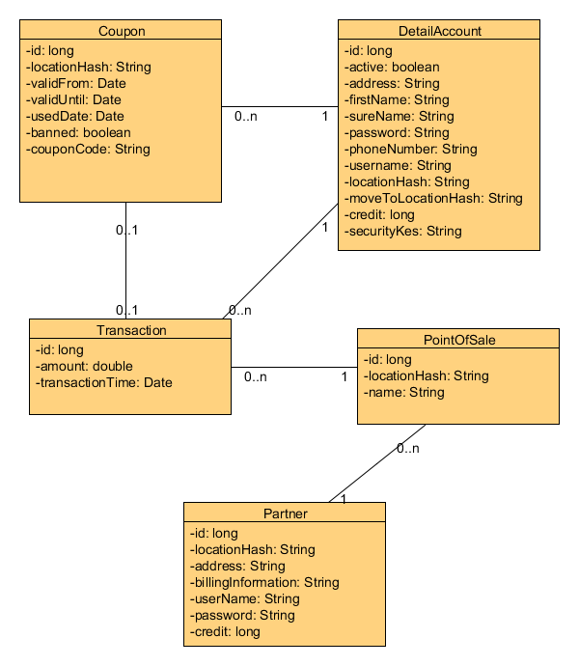
This is the basic model we use in the system. In this document we describe some design decisions which are not self-explanatory nor trivial.

General decisions
First of all we used the data type Long for amounts of money. Floating points were not acceptable for money amounts due to minor rounding issues when calculating with these formats. So we went for an Integer value instead and stored money amounts in cents. To get fixed point numbers we simply divide by 100.

Transactions
In transactions we store the involved partner and customer, the amount of money transferred and the involved coupon. For transactions from a partner to a customer we note the amount as a negative transaction.
As we store every transaction in the system in the same structure, we can easily list them in the same overview in the user interface.
Another benefit of this system is the fact that every money flow has a source and destination, so the sum of all the credits in our system must be equal to 0.

